**Odyssey Inc.**

This Agreement ("Agreement") is made and entered into on [Date], by and between Odyssey, a data broker company having its principal place of business in Bulawayo ("Odyssey"), and [Your Company Name], a company incorporated under the laws of [Jurisdiction] having its principal place of business at [Address] ("Partner").  
  
1. Services  
Odyssey agrees to provide data brokerage services to Partner, including but not limited to data acquisition, data analysis, and data dissemination in accordance with the terms of this Agreement.  
  
2. Obligations of Odyssey  
Odyssey shall use commercially reasonable efforts to provide accurate and timely data brokerage services to Partner. Odyssey shall maintain the confidentiality and security of all data shared by Partner in the course of providing the services.  
  
3. Obligations of Partner  
Partner shall provide necessary data and information to Odyssey for the purpose of data brokerage services. Partner agrees to comply with all applicable laws and regulations related to data sharing and privacy.  
  
4. Compensation  
The compensation for the data brokerage services provided by Odyssey to Partner shall be as agreed upon in a separate agreement or as mutually agreed upon by both parties.  
  
5. Confidentiality  
Both parties agree to keep all information exchanged during the course of this Agreement confidential and to use such information solely for the purpose of providing and receiving data brokerage services.  
  
6. Term and Termination  
This Agreement shall commence on the date first written above and shall continue until terminated by either party upon [Notice Period] prior written notice to the other party.  
  
7. Governing Law  
This Agreement shall be governed by and construed in accordance with the laws of [Jurisdiction].  
  
IN WITNESS WHEREOF, the parties hereto have executed this Agreement as of the date first above written.

Milton Vafana

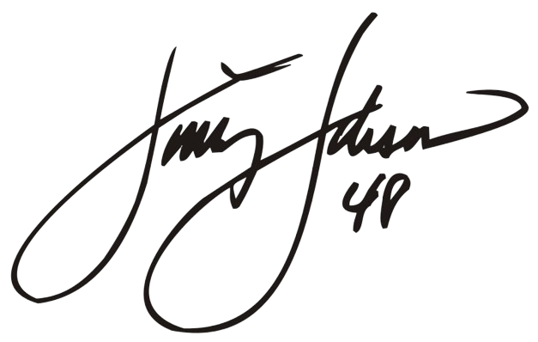

[Your Name]

*[Your Signature Here]*